THE UNITED NATIONS
SECRETARY-GENERAL’S
HIGH-LEVEL PANEL ON ACCESS
TO MEDICINES

High-Level Panel Biographies
Prepared by the High-Level Panel Secretariat at UNDP in collaboration with UNAIDS

Co-Chairs:

Festus Gontebanye Mogae: Botswana

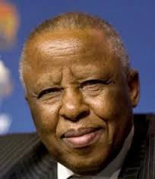
Festus Gontebanye Mogae is a citizen of Botswana. He was the President of the Republic of Botswana from 1998 to 2008. During this time, Botswana became the first African country to provide free anti-retroviral treatment to its citizens. Mr. Mogae is Chairman of Champions for a HIV Free Generation and is credited with being one of the first African leaders to publicly take a HIV test. Mr. Mogae’s outstanding leadership has ensured Botswana’s continued stability and prosperity in the face of a HIV/AIDS pandemic, which threatened the future of his country and people. He has received a number of honours; among them, the Ibrahim Prize for Achievement in African Leadership and the Grand Cross of the Légion d'honneur given to him by then French President Nicolas Sarkozy. Mr. Mogae studied Economics at the universities of Oxford and Sussex in the United Kingdom.

Ruth Dreifuss: Switzerland

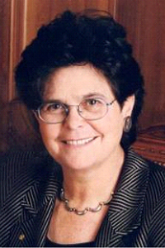
Ruth Dreifuss is a citizen of Switzerland. She was the first female President of the Swiss Confederation in 1999. From 1972 to 1981 she worked for the Directorate for Development Cooperation and Humanitarian Aid for the Federal Department of Foreign Affairs, and became Secretary of the Swiss Trade Union Federation in 1981. From 1993 to 2002, she was a member of the Swiss government and Federal Minister of Interior where her responsibilities included, amongst others, public health and scientific research. During this time, she won several referendums, including a revision of the Health Insurance Bill and the social security system. Ms. Dreifuss was also Chairperson of the Commission on Intellectual Property Rights, Innovation, and Public Health. This Commission, established by the World Health Assembly, concluded its work in 2006. One of the key messages that emerged from the Commission was that while public health remains a clear imperative for the international community, promoting medical innovations and the access to the fruits of that innovation is indispensable to progress towards improved and more equitable health outcomes. As a member of the Global Commission on Drug Policy, she supervised notably the drafting of its last report: The negative impact of drug control on public health: the global crisis of avoidable pain (October 2015). She received a Degree in Economics with special focus on econometrics from the University of Geneva.

Panelists:

Andrew Witty: United Kingdom
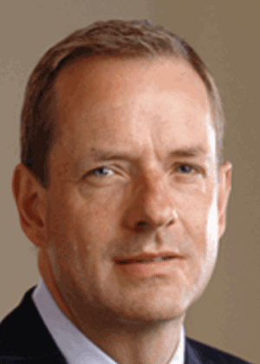
Andrew Witty is a citizen of the United Kingdom. He became Chief Executive Officer of GlaxoSmithKline in 2008. He is a member of the Board and Corporate Executive Team. Mr. Witty joined Glaxo in 1985 and has held a variety of Sales and Marketing roles in the UK and abroad including working in the Company’s International New Products groups, both in the Respiratory and HIV/Infectious disease fields. Outside of the UK, Mr. Witty has worked in South Africa, the USA and Singapore where he led the Group’s operations as Senior Vice President, Asia Pacific. In 2003 Mr. Witty was appointed President of GSK Europe and joined GSK’s Corporate Executive Team. HE has served in numerous advisory roles to governments around the world including South Africa, Singapore, Guangzhou China and the UK, where he was a member of the Prime Minister’s Business Advisory Group from 2010 - 2015. He was awarded a Knighthood for services to the economy and to the UK pharmaceutical industry in the 2012 New Year Honours List. In 2014, Andrew was appointed to be a Business Ambassador for the UK Government and in 2015, he became a member of the China-Britain Business Council Advisory Council. Andrew is Chancellor of the University of Nottingham, a position he took up on 1 January 2013. Andrew has a Joint Honours BA in Economics from the University of Nottingham.

Sakiko Fukuda-Parr: Japan

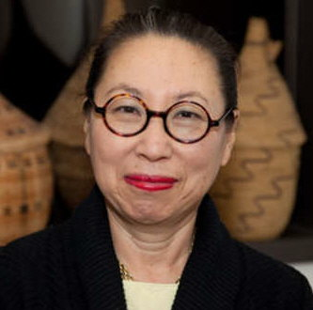
Sakiko Fukuda-Parr is a citizen of Japan. She is a development economist who has published widely on a broad range of development policy related issues and is currently a Professor of International Affairs at the New School, New York. She is also a Distinguished Visiting Fellow at the JICA Research Institute, and serves as Board Chair of Knowledge Ecology International. She is best known for her work as Director and lead author of the UNDP Human Development Reports (1995-2004). She started her career at the World Bank working on agricultural projects and moved to UNDP where she worked on aid coordination in Africa. Her current research projects include: the role of economic policy in realizing the right to food and the political economy of the Millennium Development Goals (MDGs). She is a member of the UN’s Committee on Development Policy, the Lancet-University of Oslo Commission on the Global Governance for Health. Her recent publications include: Fulfilling social and economic rights (with Lawsoon-Remer and Randolph), and MDGs, Capabilities and Human Rights: the power of numbers to set agendas (coedited with A. Yamin). Ms. Fukuda-Parr received her Master of Economics from the University of Sussex, UK and her Masters of Arts in Law and Diplomacy at The Fletcher School of Law and Diplomacy, Tufts University.

Awn Al-Khasawneh: Jordan

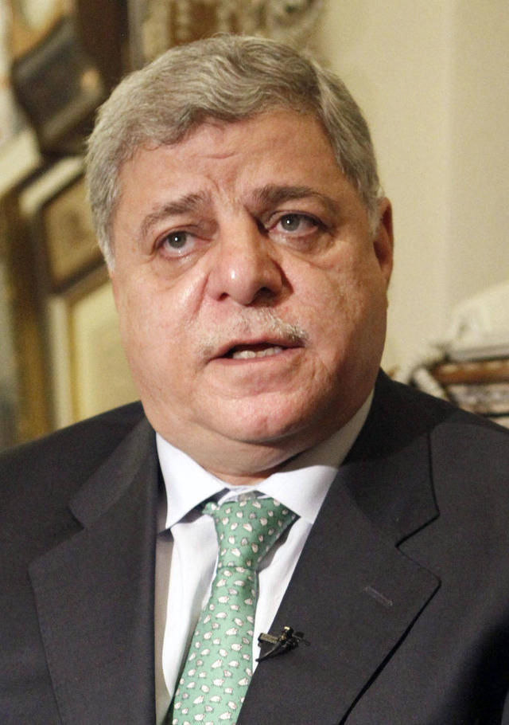
Awn Al-Khasawneh is a citizen of Jordan. He was Prime Minister of Jordan 2011-2012; Judge of The International Court of Justice 2000-2011 and its Vice President 2006-2009; and a member of the United Nations International Law Commission 1986-2000. He also served as Chief of the Royal Hashemite Court and Advisor to His Majesty the late King Hussein 1995-1998. Mr. Al- Khasawneh was educated at Queens' College, Cambridge where he is an Honorary Fellow. He lectures widely on international law and presides over international arbitrations. He is currently an Ad hoc judge on the ICJ. Most recently, he joined Doughty Street Law Chambers as a member of its Academic Panel.

Celso Amorim: Brazil
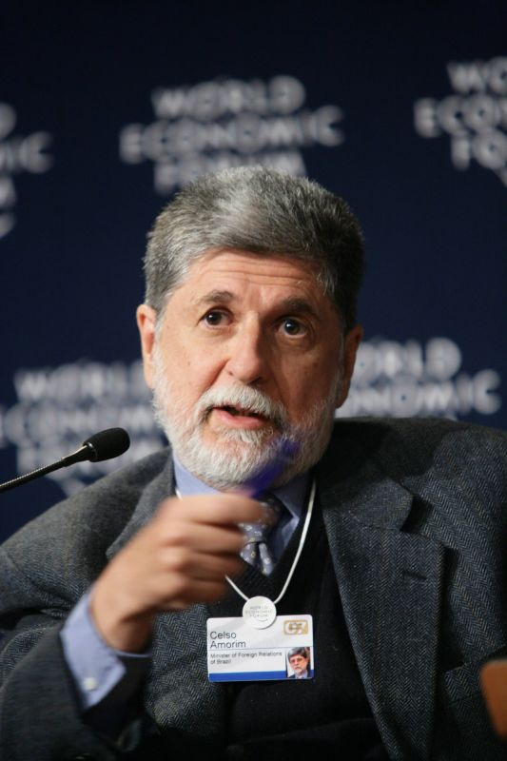
Celso Amorim is a citizen of Brazil. He is a Brazilian diplomat and a member of the Commission on Global Security, Justice and Governance. Mr. Amorim served as Brazil’s Minister of Foreign Relations from 1993 to 1995 under President Itamar Franco and again from 2003 to 2011 under President Luiz Inácio Lula da Silva, and as Minister of Defence from August 2011 to December 2014 under President Dilma Rousseff. Mr. Amorim had a long history of government service, beginning in 1987 before becoming the Director-General for Cultural Affairs in the Ministry of External Relations. While serving in the Ministry of External Relations, Mr. Amorim spent considerable time working as an Ambassador to the United Nations. Mr. Amorim was named Brazil's Permanent Ambassador to the United Nations and the World Trade Organisation and served for two years before taking assignment as the Ambassador to the United Kingdom in 2001. He has a PhD in Political Sciences, from the London School of Economics; and a postgraduate diploma in International Relations from the Diplomatic Academy, Vienna.

Winnie Byanyima: Uganda

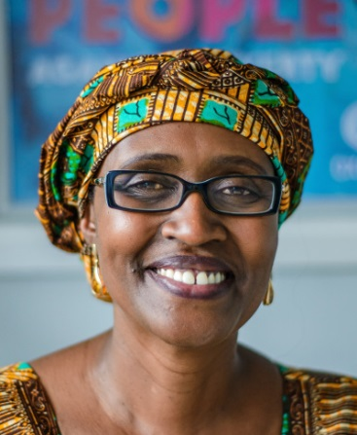
Winnie Byanyima, a citizen of Uganda, is the Executive Director of Oxfam International, a non-governmental organization with a strong focus on addressing inequalities in order to lift people out of poverty. Ms. Byanyima was a Member of Parliament for 11 years. She has also served on the African Union Commission as Director of Gender and Development, and at UNDP as Director of Gender and Development. Ms Byanyima has served on many public boards including UN commissions, advisory bodies and expert groups. She recently co-chaired the World Economic Forum in Davos.

Shiba Phurailatpam: United Kingdom

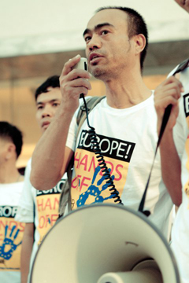
Shiba Phurailatpam is a citizen of the United Kingdom and is a treatment activist. He is the Director of the Asia Pacific Network of People Living with HIV (APN+). HIV-positive individuals from eight different countries founded APN+ in 1994 and today its membership includes nationals of 31 countries in the region. It was established in response to the need for a collective voice for people living with HIV in the region, to better link people living with HIV in the region with positive networks throughout the world, and to support regional responses to widespread stigma and discrimination and better access to treatment and care. Before joining APN+, Mr. Phurailatpam worked with the United Nations Development Programme and ActionAid International and has devoted his life to fighting for the rights of people living with HIV in India. He is a longtime treatment advocate and activist fighting for the rights of people living with HIV as well as marginalised communities.

Malebona Precious Matsoso: South Africa
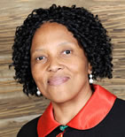
Malebona Precious Matsoso is a citizen of South Africa. She has served as the Director-General of the National Department of Health since June 2010. She has more than 20 years experience in executive management. She has held leadership positions at national and international levels for large international organizations in key strategic leadership positions, covering areas of public health policy and program development; ethics and research. She has extensive knowledge and experience with developing countries, the United Nations system, governments, and other key institutions. She was the Director at the World Health Organisation (WHO) responsible for the implementation of the Global Strategy and Plan of Action on Public Health. Prior to this she was the Director of Technical Cooperation for Essential Drugs and Traditional Medicine. She has published various articles and authored book chapters. She has been appointed to various advisory bodies both nationally and internationally. She has been a member of the WHO Executive Board and was recently appointed the Chair of the Executive Board. She has a Degree in Pharmacy from the University of the Western Cape and Post Graduate Diploma in Health Management with Honours, from the University of Cape Town. She also has a Masters in Law degree in Public Health, Law and Ethics, at Dundee University. She is currently pursuing her PhD.

Yusuf Hamied: India

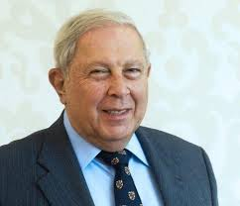
Yusuf Hamied is a citizen of India. He is a scientist and the non-executive Chairman of Cipla, a pharmaceutical company that produces generic medicines under the mantle “Caring for Life”. Dr Hamied joined Cipla as an officer-in-charge of research and development in 1960. He led major efforts to treat HIV/AIDS and neglected diseases in the developing world and to give patients life-saving medicines regardless of their ability to pay. In 2001 Cipla offered the world’s first affordable AIDS cocktail for an unprecedented cost of below dollar 1 per day. Dr Hamied has also been influential in pioneering the development of many fixed dose combination drugs for ailments including HIV, Asthma, Malaria, etc., conditions chiefly affecting developing countries. He pioneered a number of paediatric formulations of drugs to benefit children in disadvantaged settings. These innovations have greatly expanded access to medicines and increased medicine safety by ensuring appropriate dosages. Dr Hamied is highly regarded for his role in expanding the production of bulk drugs and active pharmaceutical ingredients in India. He is a recipient of India’s Padma Bhushan award in 2005 and was awarded an Honorary Doctorate by Cambridge University in 2014 and an Honorary Fellowship of the Royal Society of Chemistry.

The Honorable Michael Kirby: Australia
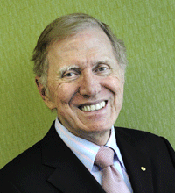
Michael Kirby is a citizen of Australia. He is an eminent jurist and academic and a retired Justice of the High Court of Australia. In 1975 he was seconded to be the inaugural Chairman of the Australian Law Reform Commission, serving in that post until 1984. Between 1978 and 1980, Michael Kirby served as the Chairman of the OECD Inter-Governmental Expert Group on Trans-border Data Flows and the Protection of Privacy. Between 1983 and 1984 he was a judge of the Federal Court of Australia. He served as the Special Representative of the United Nations Secretary General for Human Rights in Cambodia between 1993 and 1996. Mr. Kirby has served on expert or reference groups for many agencies of the UN, most recently UNAIDS, UNODC, ILO, WHO, UNDP and UNESCO. In 2007, the UN High Commissioner for Human Rights appointed him to the International Judicial Reference Group. From 2010 to 2012, Michael Kirby served as Commissioner on the Global Commission on HIV and the Law and co-chaired the Commission’s Technical Advisory Group. In May 2013 Michael Kirby was appointed by the United Nations Human Rights Council to lead a Commission of Inquiry into human rights abuses in North Korea, which produced its report in February 2014. Mr. Kirby holds a Bachelor of Arts, Bachelor of Laws, Bachelor of Economics, and Master of Laws from the University of Sydney.

Ruth Okedji: Nigeria

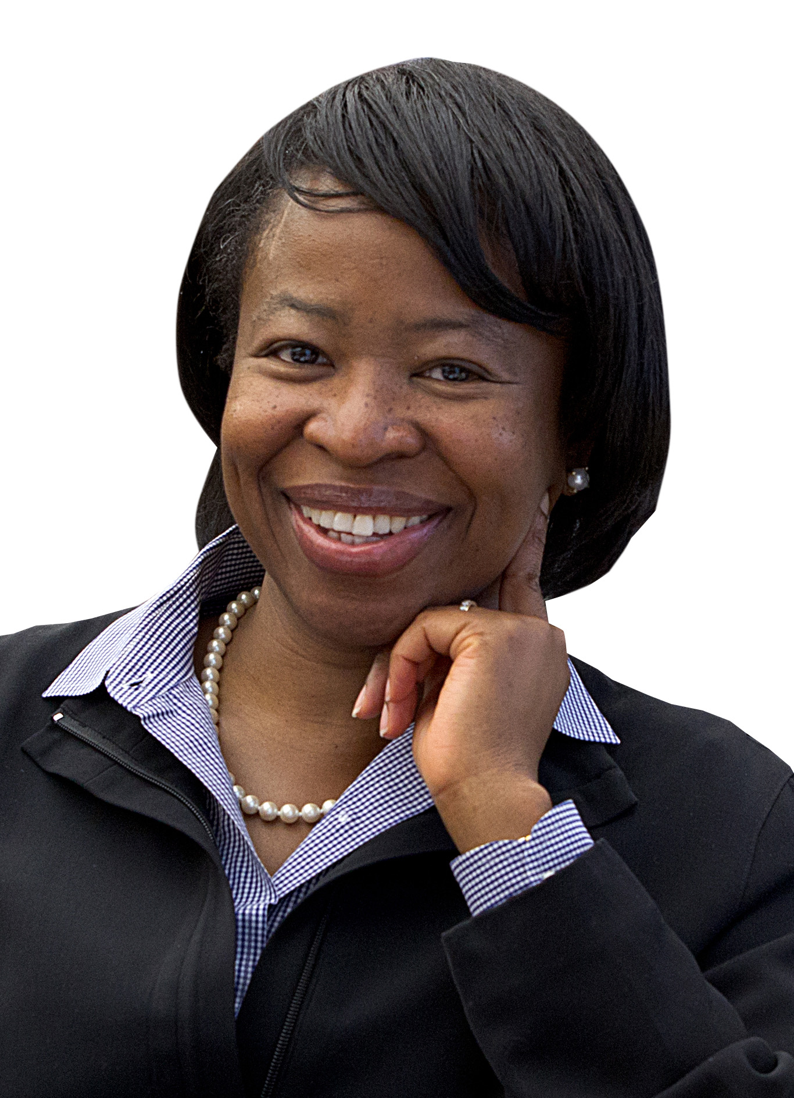
Ruth Okedji is a citizen of Nigeria. She is a Professor of Law at the University of Minnesota Law School and a visiting Professor at Harvard Law School. Ms. Okediji is an internationally renowned expert and scholar on intellectual property, trade and development. Her work on economic and human development issues related to the harmonization of intellectual property rights has been used by many national governments, international agencies and research organizations in formulating intellectual property policies at national and regional levels. She has authored an extensive array of articles and is an Editor of the Journal of World Intellectual Property. Ms. Okediji has served as a policy advisor to many inter-governmental organizations, regional economic communities and national governments on the formulation of copyright and patent policies, and on institutional design choices related to intellectual property administration. She was also a member of the National Academies' Board on Science, Technology and Policy Committee on the Impact of Copyright Policy on Innovation in the Digital Era. Ms. Okedji holds an LL.B. from the University of Jos and an LL.M. and S.J.D. at Harvard Law School.

Jorge Bermudez: Brazil
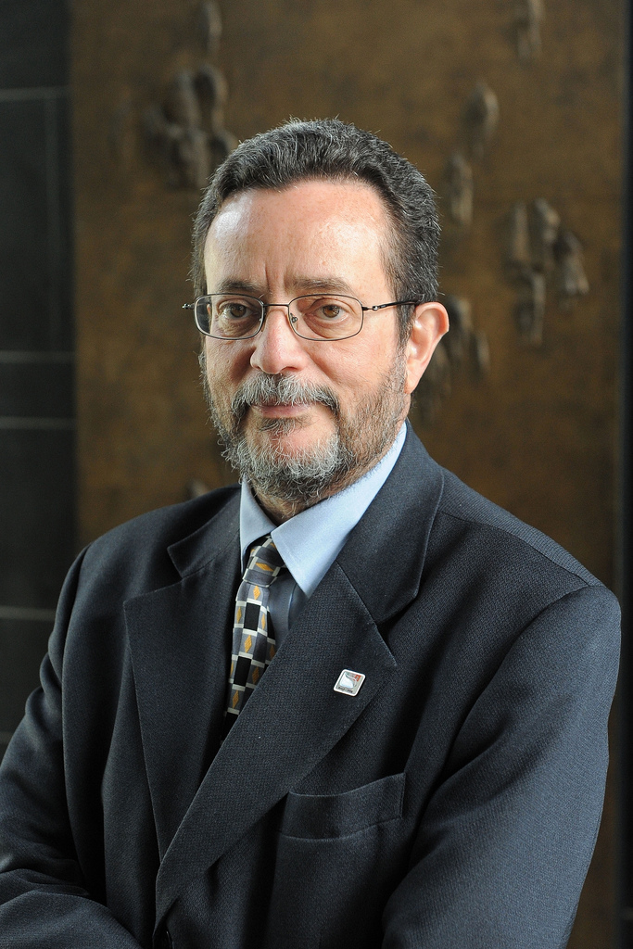
Jorge Bermudez is a citizen of Brazil. He is Vice-President of Health Production and Innovation, Fundação Oswaldo Cruz, (Fiocruz). Prior to returning to Fiocruz in 2011, he served as UNITAID Executive Director from 2007 to 2011, based in Geneva. Between 2004 and 2007, Mr. Bermudez served as Unit Chief for Medicines, Vaccines and Health Technologies Unit at PAHO/WHO, Washington DC, for the region of the Americas. Mr. Bermudez was President of the Association of Official Pharmaceutical Laboratories of Brazil (ALFOB). He played an important role in Brazil’s efforts on local production of anti-retrovirals and APIs. Additionally, he served as Deputy Executive Secretary of the Ministry of Health in 1993 and Director of Farmanguinhos (Fiocruz) between 1985 and 1987. Mr. Bermudez has published extensively on issues such as public health, pharmaceutical policies, access to medicines and intellectual property. He holds a degree in Medicine and Masters in Infectious and Parasitic Diseases (Tropical Medicine) both from the Rio de Janeiro Federal University (UFRJ). He has a Doctorate of Science in Public Health from ENSP, Fiocruz.

Dr. Kinga Göncz: Hungary

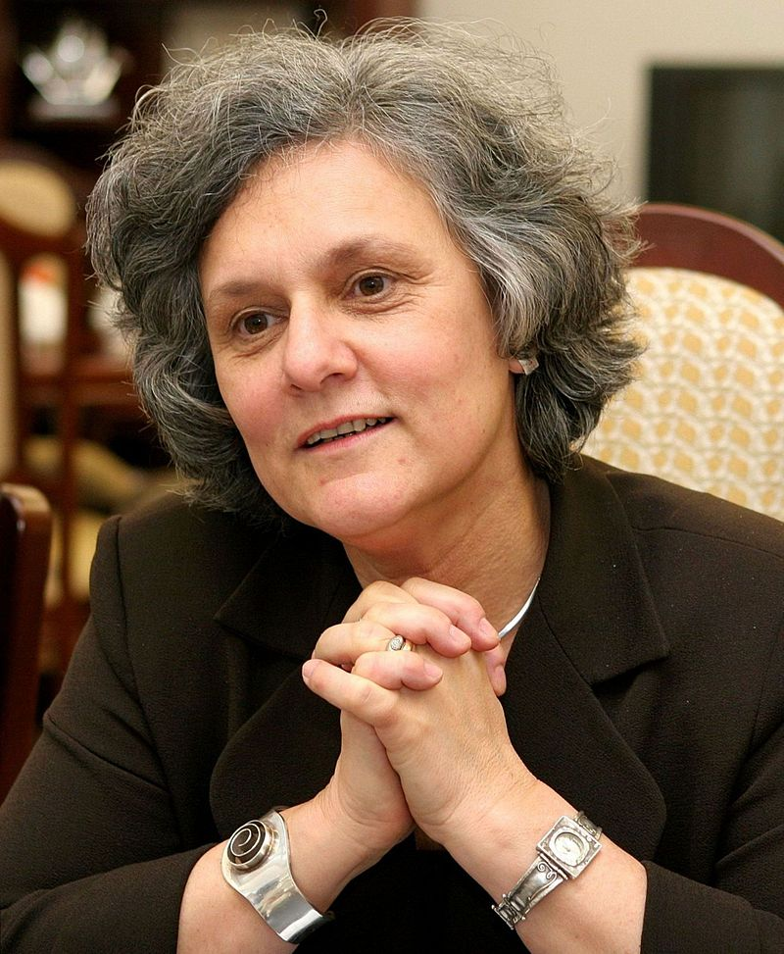
Kinga Goncz is a citizen of Hungary. She is a Visiting Professor at the School of Public Policy of the Central European University and Chair of the Roma Advisory Board at the Open Society Foundations. She has extensive experience in government and civil society. As a distinguished academician, from 1989 to 2002 she was the Associate Professor at the Social Policy and Social Work Department of the Institute for Sociology at ELTE University in Budapest. Additionally she taught courses at the Human Rights Department at Central European University. Between 1994 and 2002 she was the Director of Partners Hungary Foundation, a member of a US- founded international network teaching democracy skills, negotiation and mediation. Ms. Goncz has also held many positions in the Hungarian government – including Minister of Social Affairs and Equal Opportunities and Minister of Foreign Affairs between 2002 and 2009. She was also a member of the European Parliament from 2009 to 2014. She began her carrier as a medical doctor after graduating from the Semmelweis University of Medicine in Budapest in 1972. She later specialized in psychiatry and psychotherapy. In 2004 she obtained her diploma in psychotherapy from the European Association for Psychotherapy.

Maria Freire: United States

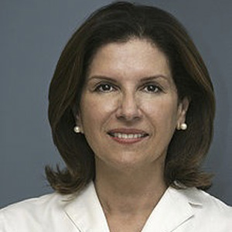
Maria Freire, a citizen of the United States, is President and Executive Director of the Foundation for the National Institutes of Health (FNIH) and is a member of the Science Board of the US Food and Drug Administration. From 2001 to 2008, she was the President and Chief Executive Officer of the Global Alliance for TB Drug Development. An internationally recognized expert in technology commercialization, she directed the Office of Technology Transfer at the United States National Institutes of Health (NIH) from 1995 to 2001. Dr. Freire served as one of 10 Commissioners on the Commission on Intellectual Property Rights, Innovation and Public Health (CIPIH), established by the World Health Assembly. She obtained her B.S. degree at the Universidad Peruana Cayetano Heredia in Lima, Peru, her Ph.D. in Biophysics from the University of Virginia and completed post-graduate work in immunology and virology at the University of Virginia and the University of Tennessee.

Stephen Lewis: Canada
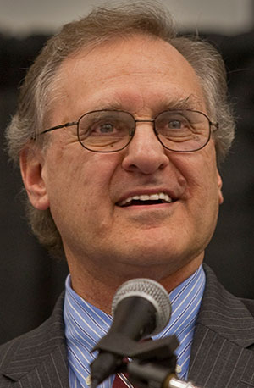
Stephen Lewis is a citizen of Canada. Mr. Lewis is co-founder and co-director of the advocacy organization AIDS-Free World. He is co-founder and Board Chair of the Stephen Lewis Foundation. Mr. Lewis is a Professor of Distinction at Ryerson University in Toronto and Professor of Practice in Global Governance at McGill University. He is a past member of the Board of Directors of the Clinton Health Access Initiative and Emeritus Board Member of the International AIDS Vaccine Initiative. He served as a Commissioner on the Global Commission on HIV and the Law. Mr. Lewis was the UN Secretary-General’s Special Envoy for HIV/AIDS in Africa (2001-06); Deputy Executive Director of UNICEF (1995 -1999); and he served as Canada’s Ambassador to the UN (1984-1988). From 1970-1978, Mr. Lewis was leader of the Ontario New Democratic Party, during which time he became leader of the Official Opposition. Mr. Lewis is a Companion of the Order of Canada and has 40 honorary degrees from Canadian and American universities.

