THE UNITED NATIONS
SECRETARY-GENERAL’S
HIGH-LEVEL PANEL ON ACCESS
TO MEDICINES

Expert Advisory Group Biographies
Prepared by the High-Level Panel Secretariat at UNDP in collaboration with UNAIDS

World Health Organization (WHO)

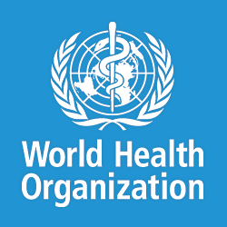
The World Health Organization (WHO) is a specialized agency of the United Nations (UN) concerned with international public health. Its current priorities include communicable diseases, in particular HIV/AIDS, Ebola, malaria and tuberculosis; the mitigation of the effects of non-communicable diseases; sexual and reproductive health, development, and aging; nutrition, food security and healthy eating; occupational health; substance abuse; and driving the development of reporting, publications, and networking.

World Intellectual Property Organization (WIPO)

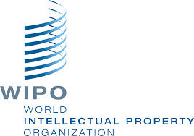
The World Intellectual Property Organization (WIPO) is the global forum for intellectual property services, policy, information and cooperation. WIPO is a self-funding agency of the United Nations, with 188 member states. Their mission is to lead the development of a balanced and effective international intellectual property (IP) system that enables innovation and creativity for the benefit of all.

The World Trade Organization (WTO)

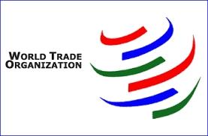
The World Trade Organization (WTO) is an intergovernmental organization which regulates international trade. The WTO deals with regulation of trade between participating countries by providing a framework for negotiating trade agreements and a dispute resolution process aimed at enforcing participants' adherence to WTO agreements, which are signed by representatives of member governments and ratified by their parliaments.

United Nations Industrial Development Organization (UNIDO)
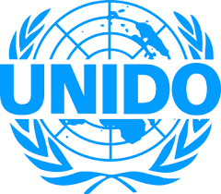
The United Nations Industrial Development Organization’s (UNIDO) primary objective is the promotion and acceleration of industrial development in developing countries and countries with economies in transition and the promotion of international industrial cooperation. UNIDO therefore works towards improving the quality of life of the world's poor by drawing on its combined global resources and expertise.

United Nations Conference on Trade and Development (UNCTAD)

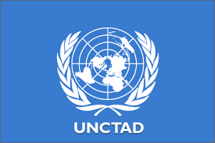
The United Nations Conference on Trade and Development (UNCTAD) is the principal organ of the United Nations General Assembly dealing with trade, investment, and development issues. The organization's goals are to: maximize the trade, investment and development opportunities of developing countries and assist them in their efforts to integrate into the world economy on an equitable basis.

United Nations Children’s Fund (UNICEF)

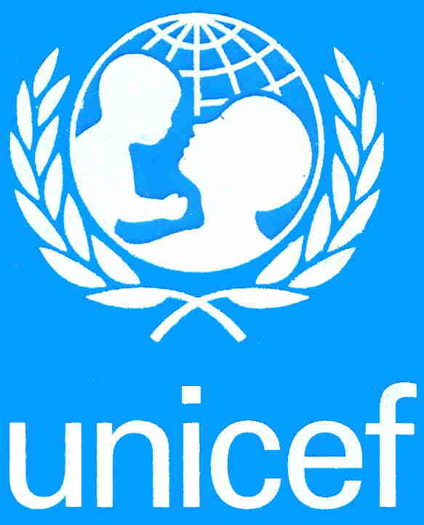
UNICEF is a leading humanitarian and development agency working globally for the rights of every child. UNICEF has spent nearly 70 years working to improve the lives of children and their families. UNICEF also lobbies and partners with leaders, thinkers and policy makers to help all children realize their rights—especially the most disadvantaged.

Office of the High Commissioner for Human Rights (OHCHR)

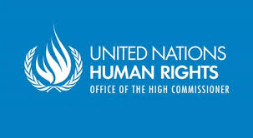
The Office of the United Nations High Commissioner for Human Rights (OHCHR) is a United Nations agency that works to promote and protect the human rights that are guaranteed under international law and stipulated in the Universal Declaration of Human Rights of 1948. The office is headed by the High Commissioner for Human Rights, who co-ordinates human rights activities throughout the UN System and supervises the Human Rights Council in Geneva, Switzerland.

The United Nations Special Rapporteur on the Right to Health

Special Rapporteurs are independent experts appointed by the Human Rights Council to examine a situation or a specific human rights theme. The right to health is an inclusive right, extending not only to timely and appropriate health care, but also to the underlying determinants of health.

The Joint United Nations Programme on HIV/AIDS (UNAIDS)

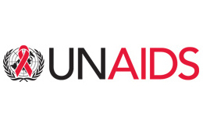
The Joint United Nations Programme on HIV and AIDS, or UNAIDS, is the main advocate for accelerated, comprehensive and coordinated global action on the HIV/AIDS epidemic. The mission of UNAIDS is to lead, strengthen and support an expanded response to HIV and AIDS that includes preventing transmission of HIV, providing care and support to those already living with the virus, reducing the vulnerability of individuals and communities to HIV and alleviating the impact of the epidemic. UNAIDS seeks to prevent the HIV/AIDS epidemic from becoming a severe pandemic.

United Nations Development Programme (UNDP)

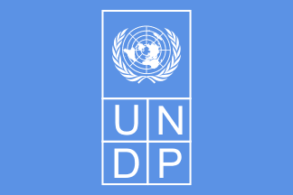
The United Nations Development Programme (UNDP) is the United Nations' global development network. UNDP advocates for change and connects countries to knowledge, experience and resources to help people build a better life. It provides expert advice, training, and grant support to developing countries, with increasing emphasis on assistance to the least developed countries. The UNDP focuses on poverty reduction, HIV/AIDS, democratic governance, energy and environment, social development, and crisis prevention and recovery. UNDP also encourages the protection of human rights and the empowerment of women in all of its programmes.

Carlos Correa: Argentina
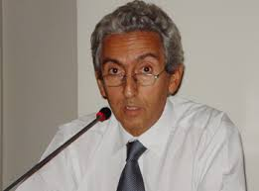
Professor Carlos Maria Correa is Director of the Center for Interdisciplinary Studies on Industrial Property and Economics, manages the post-graduate course on Intellectual Property, and the Masters Program on Science and Technology Management, at the University of Buenos Aires. He is also Special Advisor on Trade and Intellectual Property at South Centre. He has been a visiting professor at several universities and has consulted for UNCTAD, UNIDO, UNDP, WHO, FAO, IDB, INTAL, World Bank, SELA, ECLA, and other regional and international organizations. He has advised several governments on intellectual property, innovation policy and public health. He was a member of the Commission on Intellectual Property (CIPR) established by the UK Government, a member of the Commission on Intellectual Property, Innovation and Public Health (CIPIH) established by the World Health Assembly and a member of the FAO Panel of Eminent Experts on Ethics in Food and Agriculture. Professor Correa gained his law and economics degrees, as well his PhD in law, from the University of Buenos Aires.

Dominique Foray: France

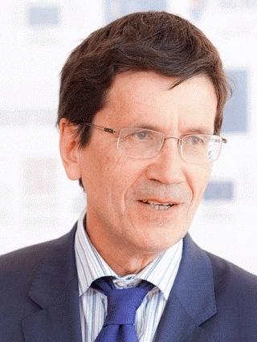
Dominique Foray is a Full Professor at the Ecole Polytechnique Fédérale de Lausanne and holds the Chair of Economics and Management of Innovation. Professor Foray is recognized as one of the leading academic experts in the economics of innovation and knowledge and economic policy implications of the new knowledge-based economy. He is a member of the National Research Council (Switzerland); the Advisory Board of the Swiss Economic Institute; the World Economic Forum’s Global Agenda Council; and a foreign member of the Center of Capitalism and Society at Columbia University, New York. He is also a member of the Expert Commission for Research and Innovation of Germany. Professor Foray’s research interests include the economics and management of technology, knowledge and innovation at both the micro and macro levels. This broad field covers the economics of science and technology with a particular focus on high tech sectors, the management of large-scale technological projects, international comparisons of institutions, and systems of innovation within the context of the new economy. Fields of high relevance in his research include intellectual property and competition policies, information technology and the new economy, capital markets and entrepreneurship and national systems of innovation. Professor Foray received his PhD from the Université Lumière of Lyon.

Frederick M. Abbott: United States

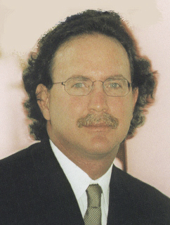
Frederick Abbott is the Edward Ball Eminent Scholar Professor of International Law at Florida State University College of Law. He has served as an expert consultant for numerous international and regional organizations, governments and nongovernmental organizations, in the fields of intellectual property, public health, trade and sustainable development. Mr. Abbott is the author of many books and articles in the fields of international intellectual property rights law, public health, international law and international economic law. He is the Co-Chair of the Committee on Global Health Law of the International Law Association, having served as Rapporteur for the Committee on International Trade Law from the inception of its work in 1993 to its conclusion in 2014. He is a consultant to the World Health Organization, the United Nations Development Program and other multilateral institutions. He has served as counsel to governments in WTO dispute settlement proceedings, and in national court proceedings. Mr. Abbott is Co-Director of the Executive Course on Intellectual Property, Diplomacy and Global Public Health for the Global Health Programme of the Graduate Institute, Geneva. He is a graduate of the Yale Law School and the University of California, Berkeley.

Suerie Moon: United States

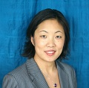
Suerie Moon co-directs the Project on Innovation and Access to Technologies for Sustainable Development at the Harvard Kennedy School of Government. She also leads the Forum on Global Governance for Health at the Harvard Global Health Institute, and teaches at the Harvard T.H. Chan School of Public Health and Kennedy School. Recently, she served as Study Director of the Harvard-LSHTM Independent Panel on the Global Response to Ebola. Dr. Moon’s work focuses on the intersection of global governance and public health, including the trade and investment regimes, intellectual property rules, policies to enhance innovation & access to medicines in low- and middle-income countries, global health financing, and the political economy of the global health system. Previously, she worked in New York, Geneva, Paris, Goma (DRC), and Beijing for Médecins Sans Frontières (MSF) where she focused on innovation and access to medicines, and humanitarian assistance in conflict settings. She has also consulted for a number of non-governmental organizations, think tanks, and intergovernmental organizations on global governance and access to medicines issues. Dr. Moon is a member of the editorial board of PLoS Medicine, Global Health Governance Journal, Board of Directors of MSF-USA, the Drugs for Neglected Diseases Initiative-North America, and the Proposal Review Committee of UNITAID. She received her BA from Yale University, MPA from Princeton University, and PhD from the Harvard Kennedy School. She is the author (with Wolfgang Hein) of the book: Informal Norms in Global Governance: Human Rights, Intellectual Property and Access to Medicines (2013).

Manica Balasegram: United Kingdom

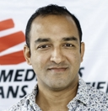
Manica Balasegaram is the Executive Director of the Access Campaign at Médecins Sans Frontières (MSF). He joined MSF in 2001, working as a doctor in the field in several countries in sub-Saharan Africa and southern Asia. After gaining significant operational research experience, Dr. Balasegaram became Head of the Manson Unit, a London-based medical research and implementation arm of MSF, in 2005. He joined the MSF partner organisation Drugs for Neglected Diseases initiative (DNDi) in 2008, where he worked for four and a half years, finishing as DNDi’s Head of Leishmaniasis Clinical Development Team. Dr. Balasegaram has worked extensively on issues around access to medicines with a particular focus on tropical and neglected diseases, having significant work experience in both areas, and having trained in both Public Health and Tropical Medicine from the London School of Hygiene and Tropical Medicine. He also has substantial experience in clinical trials and drug development working as a site investigator, principal investigator and project manager. Dr. Balasegaram is a medical doctor who trained at the University of Nottingham. He received further post-graduate training in internal and emergency medicine in the UK and Australia.

Lorena Di Giano: Argentina

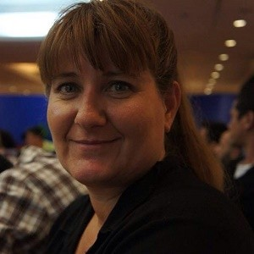
Maria Lorena Di Giano is Executive Director of Fundacio Grupo Efecto Positivo and General Coordinator of RedLam - FGEP is the leading organization of RedLAM. Currently, she is coordinating a regional program focused on improving access to ARVs by addressing intellectual property barriers in countries of Latin American region. She is a lawyer who specializes in Human Rights and HIV and AIDS. She is an experienced advocate who has dedicated her professional background to defending the human rights of people living with HIV (PLHIV), especially women living with HIV/AIDS. She has offered legal support and representation for PLHIV in local and national courts in Argentina, as well as at the Inter‐ American Commission on Human Rights, in cases of human rights violations. In the past she has worked for the Argentinean Network of Women Living with HIV/AIDS, as the Project Manager and Campaigner, and also undertaken out facilitation and training activities in topics such as human rights, gender, leadership and advocacy. From 2004 and 2007 she has served as a member of UNAIDS Theme Group in Argentina, representing people living with HIV. She has a law degree from Universidad Nacional de Mar del Plata in Argentina.

Richard Elliot: Canada

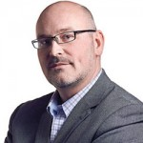
Richard Elliott is the Executive Director of the Canadian HIV/AIDS Legal Network, a human rights NGO working domestically and internationally on legal and human rights issues raised by HIV and AIDS. He has worked as a civil litigator in private practice, has appeared before the Supreme Court of Canada, and has helped guide the HIV/AIDS Legal Network’s litigation in key HIV-related court cases in Canada and internationally. He was a member for six years of the Ministerial Council on HIV/AIDS, the advisory body to Canada’s Minister of Health, and also served as a member of the Technical Advisory Group of the Global Commission on HIV and the Law. Mr. Elliott is a member of the International Advisory Committee of the International Centre for Human Rights and Drug Policy and a founding member of the Global Treatment Access Group (GTAG), an affiliation of Canadian civil society organizations advocating for access to medicines and other aspects of the human right to health in developing countries. In addition, Mr. Elliott has authored numerous reports, papers and articles on a range of human rights issues, appeared before legislative committees, served as an expert resource to UN agencies, and presented extensively on HIV and human rights across Canada and internationally. Mr. Elliott holds an undergraduate honours degree in economics and philosophy from Queen’s University in Kingston, Ontario, and obtained his LL.B. and LL.M. from Osgoode Hall Law School in Toronto.

Susan Sell: United States

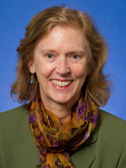
Susan Sell is a Professor of Political Science and International Affairs at the Elliot School of International Affairs – a professional school of international relations founded in 1898 as the School of Comparative Jurisprudence and Diplomacy at the George Washington University. She has published extensively on issues of global governance and intellectual property. Key publications include: ‘Who Governs the Globe?’; ‘Intellectual Property Rights: a Critical History’; ‘Private Power, Public Law: the Globalization of Intellectual Property Rights’; ‘Historical Institutionalism and the International Regulation of Intellectual Property’; ‘Corporations, Seeds, and Intellectual Property Rights Governance’ in Clapp and Fuchs eds.; ‘Power and Private Interests in Global Agro-Food Governance 3’; ‘Business and Democracy? Pharmaceutical Firms, Intellectual Property and Developing Countries"’ in Porter and Ronit eds; ‘The Challenges of Global Business Authority: Democratic Renewal, Stalemate or Decay? Professor Sell received her B.A. in political science from Colorado College, her M.A. in political science from the University of California, Santa Barbara, and her Ph.D. from the University of California, Berkeley.

Marc LaForce: United States
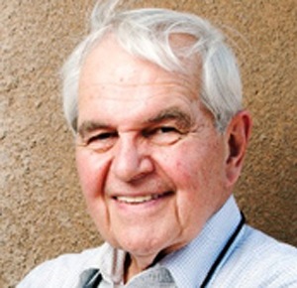
Marc LaForce was founding director of the Meningitis Vaccine Project, a Gates Foundation-funded partnership between PATH and the World Health Organization (WHO) aimed at eliminating epidemic meningitis from sub-Saharan Africa through the development, licensing, and widespread use of conjugate meningococcal vaccines. He directed the project from 2001 until his retirement in 2012. During this time he led the successful development, licensing and introduction of MenAfriVac®, the first vaccine designed specifically for Africa. Before joining PATH, Dr. LaForce held academic and administrative positions at the University of Colorado and the University of Rochester Schools of Medicine. He also served on immunization advisory committees for the US Centers for Disease Control and Prevention and for the American College of Physicians. From 1994 to 2001, he led the Steering Committee on Epidemiology and Field Research for WHO’s vaccine cluster. From 1998 to 2001, he was president of the US Armed Forces Epidemiological Board. Dr. LaForce received his medical degree from Seton Hall College of Medicine and Dentistry and completed his internal medicine and infectious diseases training on the Harvard Service at Boston City Hospital.

Paul Stoffels: Belgium
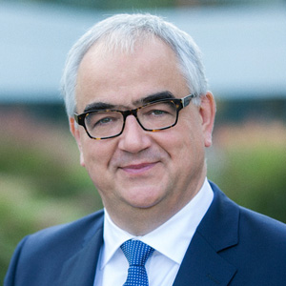
Paul Stoffels is the Chief Scientific Officer of Johnson & Johnson, chairing the Johnson & Johnson Research and Development Management Committee and providing oversight to the Johnson & Johnson Development Corporation (JJDC) and the Johnson & Johnson Innovation centers. He is also Worldwide Chairman of Pharmaceuticals, Johnson & Johnson, with responsibility for expansion of the company’s therapeutic pipeline through global Research and Development and strategic partnerships, licensing and acquisitions. He oversees teams across the Janssen Pharmaceutical Companies of Johnson & Johnson on medicine development. Stoffels began his career as a physician and researcher of HIV/AIDS in Africa. In 1991, he returned to Belgium and became the Head of Development for the HIV compounds at Janssen Pharmaceutical in Beerse, Belgium. In 1993 he was promoted to the post of Director of Clinical Research and Development for Infectious Diseases and Dermatology. In 1997, he left Janssen Pharmaceutical and, together with Rudi Pauwels, co-founded the biotech companies Tibotec and Virco. Mr. Stoffels joined Johnson & Johnson in 2002 where he was Chief Executive Officer, and led the development of a number of products for the treatment of HIV. Mr. Stoffles studied Medicine at the University of Diepenbeek and the University of Antwerp in Belgium, and Infectious Diseases and Tropical Medicine at the Institute of Tropical Medicine in Antwerp.

Anand Grover: India

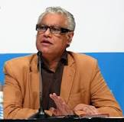
Anand Grover is a lawyer and co-founder of Lawyers Collective – a leading civil society group in India focused on focusing on human rights and public interest issues. From 2008 to 2014, Grover served as the UN Special Rapporteur on the Right to the highest attainable standard of health. He is a member of the Lancet-University of Oslo Panel on Global Governance of Health. He was a member of the drafting group of the International Guidelines on Human Rights & HIV/AIDS and a Board Member of AVAHAN, the India AIDS Initiative of the Bill and Melinda Gates Foundation. Mr. Grover is a Board Member of International AIDS Vaccine Initiative and a member of the National Advisory Body of the World Care Council. As a lawyer, Mr. Grover has argued many cases relating to the rights of people living with HIV, including patent cases to make medicines accessible in India and in other developing countries. Some notable cases include the Novartis case (relating to patentability criteria and the cancer drug Imatinib) and the Natco case (relating to compulsory license of the cancer drug Sorafenib). Grover received his LLB, Bombay University.

Anthony So: United States

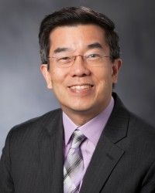
Anthony So currently directs the Program on Global Health and Technology Access at the Sanford School of Public Policy, Duke University. He will soon join the Johns Hopkins’ Bloomberg School of Public Health as the inaugural Robert S. Lawrence Professor in the Department of Environmental Health Sciences and as Director of the Center for a Livable Future. His work addresses issues of globalization and health equity, from innovation and access to health technologies. He also leads the strategic policy program of ReAct, a global network dedicated to meeting the challenge of antibiotic resistance. He has served on The Lancet Infectious Diseases’ Commission on Antibiotic Resistance and has chaired a World Health Organization (WHO) expert working group on fostering innovation to combat antimicrobial resistance. Prior to joining Duke, Professor So was associate director of Health Equity at the Rockefeller Foundation, where his strategic approach to grant-making improved access to HIV/AIDS medicines in low- and middle-income countries. Professor So received a BA in philosophy and biomedical sciences and an MD from the University of Michigan. He was awarded a Masters in Public Policy as a Woodrow Wilson Scholar at Princeton University and subsequently trained in internal medicine at the Hospital of the University of Pennsylvania.

